Minikube start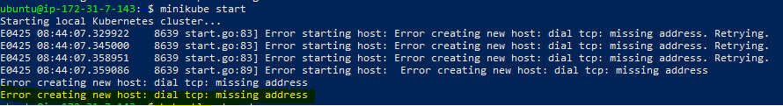

**Eror-2:**

**Command: kubectl get svc**

**Error: The connection to the server localhost:8080 was refused - did you specify the right host or port?**

**Solution: aws eks --region** *region-code* **update-kubeconfig --name** *cluster_name*